**Project Design Phase-II**

**Data Flow Diagram & User Stories**

|  |  |
| --- | --- |
| Date | 17 October 2022 |
| Team ID | B2-2M4E |
| Project Name | Skill/job recommender |
| Maximum Marks | 4 Marks |

**Data Flow Diagrams:**

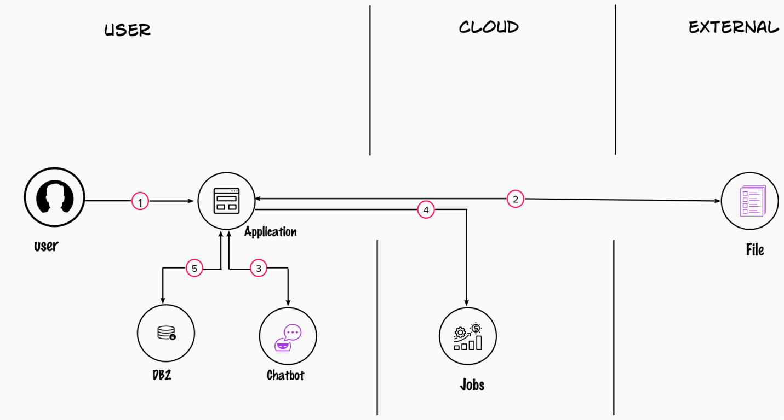

l